|  |
| --- |
|  |

|  |
| --- |
|  |

**Welcome**

**Extreme Radiology’s VIPs Presentation**

**Future of Medical Imaging- A Disruptive Technology**

|  |
| --- |
|  |

|  |
| --- |
|  |

**Typical PACs**

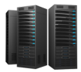

**DICOM Viewer**

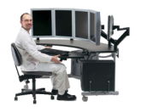

**Modality** (MR)

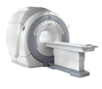

**Modality** (CT)

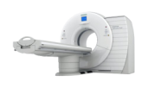

**Modality** (US)



**DICOM Directory**

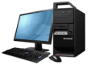

**PACS**  
(Picture Archiving and   
Communication System)

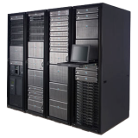

**Mobile   
DICOM   
Viewer**

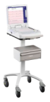

**PACS Staff**



**VPN**

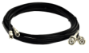

**High Bandwidth Connections**

**Equipment &  
Maintenance**

**Viewers for each viewing station**

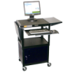

**High Power Work Stations**

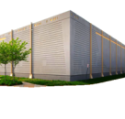

**Offsite Storage**

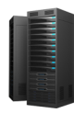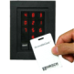

**Dual-Card Door Entry System Servers**

|  |
| --- |
|  |

|  |
| --- |
|  |

**Extreme Radiology’s Innovative VIPs (Virtual Image Processing System)**

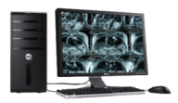



**High Power Work Stations**



**VPN**



**High Bandwidth Connections**



**Dual-Card Door Entry System Servers**

**Modality** (MR)



**Modality** (CT)



**Modality** (US)



**DICOM Viewer**

**DICOM Directory**



**PACS**  
(Picture Archiving and   
Communication System)



**Mobile   
DICOM   
Viewer**



**PACS Staff**



**Offsite Storage**

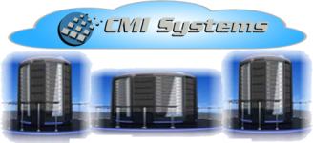

|  |
| --- |
|  |

**Extreme Radiology’s Innovative VIPs (Virtual Image Processing System)**

**comps.png**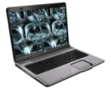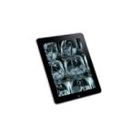

**Extreme Radiology fully integrates or replaces current PACs**

**Systems, PACs can be used as on site storage. No extra training needed, all processes are the same before and after Extreme Radiology integration. However, it will run faster, more reliable, more secure, productivity will increase dramatically with the ability to use any device, and costs will decrease drastically.**

**Extreme Radiology VIPs**

**Modality** (MR)



**Modality** (CT)



**Modality** (US)



|  |
| --- |
|  |

**VIPs SECURITIES/DATA CENTERS**

* **Extreme Radiology utilizes 2048 Bit Encryption**
* **10 times HIPAA (128bit) Compliance**
* **Instant redundancy and colocation back-up**
* **7 + Internet Service Providers (ISP)**
* **N+1 / Uninterruptible Power Supply (UPS)**
* **Backup generators with 100% peak load**
* **SAS 70 (SOC II) Auditing**
* **Disaster Recovery Plan (DRP)**
* **Onsite Security**
* **Closed circuit digital camera monitoring**
* **Armed centralized security stations**
* **Biometric palm and iris scanners/card readers**
* **Assigned authenticated access**

|  |
| --- |
|  |

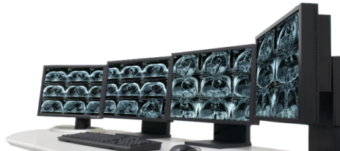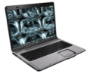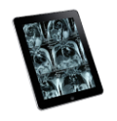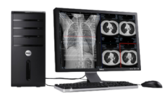**TURN ANY DEVICE INTO HIGH POWER WORKSTATION**

* True Zero-Footprint with no download or cache
* No more RIS, PACS, EHR training
* Any viewing software (GE, Phillips, McKesson)
* On-site / Hospital or PACS workstation
* Off-site / Office Workstation
* Home Office / Laptop
* I-Pad -Android/ Smart Phone

|  |
| --- |
|  |

|  |
| --- |
|  |

|  |
| --- |
|  |

**CLIENT COST CUTTING AREAS**

**PACS**  
(Picture Archiving and   
Communication System)



* CD & Image Delivery Costs
* PACS & PACS Service Contracts
* Bandwidth, VPN Installs, Fiber Connections
* Hardware, Software & Workstation upgrades
* HIPAA and Colocation / Backup requirements
* Vendor Neutral Archiving (VNA) & Data Migration

|  |
| --- |
|  |





**High Bandwidth Connections**



**VPN**

**DICOM Viewer**



**Offsite Storage**

**VIPS UNBELIEVABLE SAVINGS**

|  |
| --- |
|  |

* **Zero hardware or capital outlay for customers**
* **Integrates quickly into any platform**
* **PACS, RIS, EMR, EHR**
* **No maintenance fees**
* **Up & running in minutes**
* **Pay per study, volume based pricing**
* **Only pay for what you need**
* **Customized pricing plans to fit your needs**
* **Any Device Can be used as a high end Power Station**
* **Diagnostic Standard Images**
* **Completely Eliminates PACS**
* **Accommodates the entire workflow**

|  |
| --- |
|  |

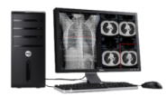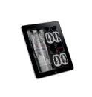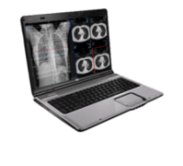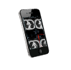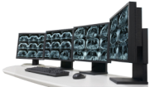**mri.png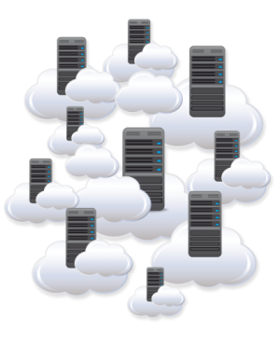EXISTING PACS FREE TRIAL STRUCTURE**

**Existing PACS**  
(Picture Archiving and   
Communication System)



Extreme Radiology

Use each system concurrently

|  |
| --- |
|  |

|  |
| --- |
|  |

**PATENT-PROTECTION**

* **Extreme Radiology VIP system is Completed Patented**
* **Applied patent in September 2012**
* **Received Patent in 2013**
* **Software notdeployed at client level**
* **Source Code Never leaves the Network**
* **Tier 4 Data Center, unhackable**
* **End to end protection**
* **100% containment of intellectual property**

|  |
| --- |
|  |

**CLIENT COSTS/ROI**

* **Standard Industry Cost 4-12 Dollar per Study**
* **VIPs deployed solution will reduce the cost by minimum 50%**
* **Average Studies per Annum/Hospital = 1 Million**
* **Median Cost = $7/Study x 1 Million = $7 Million in Revenue/Annum**
* **VIPs Cost Saving = 50% = $3.5 Million/Annum**
* **No upfront investment for the Client.**
* **Complete Eliminates PACs**
* **No Maintenance Needed**
* **No Training Needed**
* **Can Be deployed and ready to use in less than an Hour**
* **No Backups**
* **Complete Disaster Recovery**
* **Complete Referral Provide workflow built in**

|  |
| --- |
|  |

|  |
| --- |
|  |

**END OF PRESENTATION**

**FOR QUESTIONS KINDLY EMAIL TO** [**support@medginix.com**](mailto:support@medginix.com)

**Or Call Dr. Ajay Goyal: 772-971-0252**